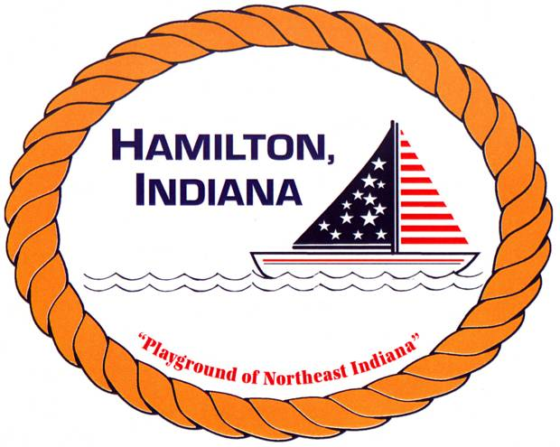

HAMILTON TOWN BEACH SWIMMING LESSON

REGISTRATION FORM

Child(ren) Name _________________________________________________________

Sex & Ages _____________________________________________________________

Parent/Guardian Name ___________________________________________________

Phone - ________________________________________________________________

June 25-29, 2019 and July 15-19, 2019 (please circle the week you will be attending)

Circle the Skill Level:

Level 1 – 4:30 – 5:00 pm (ONLY IN JULY)
Level 2 –5:00-5:30 pm
Level 3 –5:30-6:00 pm
Level 4 –6:00-6:30 pm
*Participation in a class is based on first come, first served.

Please answer the following questions about your child’s swim level.
Can your child float: on his/her stomach or back? YES_____ NO_____
Can your child put their head under water? YES_____ NO_____
On a scale from 1-10 please circle his/her comfort level in any water depth:
Afraid: 1 2 3 4 5 6 7 8 9 10: Comfortable

Does your child have any medical conditions that could interfere with swimming? (For example, asthma) __________________________________________________

I agree to allow my son/daughter to attend swim lessons at Hamilton Town Beach. My child cannot leave the premises on her/his own.

Parent Signature: _________________________________________________________

In the event that a parent can not pick son/daughter up, I authorize the following person/s.

Person Authorized ___________________________ Tel: _______________________

PLEASE NOTE:CLASSES WILL ONLY BE CANCELLED IN THE EVENT OF RAIN, THUNDER, AND/OR LIGHTNING.

