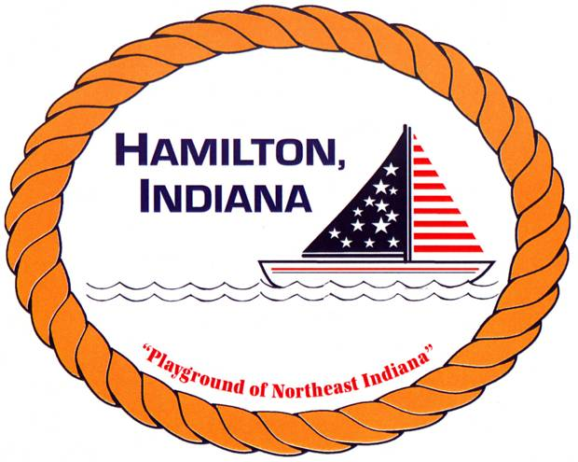

HAMILTON TOWN STORY & A CRAFT

REGISTRATION FORM

Child(ren) Name _________________________________________________________

Sex & Age ______________________________________________________________

Parent/Guardian Name ___________________________________________________

Phone _________________________________________________________________

June 3-7, 2019 & July 8-12th, 2019– (Please circle the week you will be attending)
3-4 year olds – 9:15 – 10:00 am – LIMIT 10
5-6 year olds – 10:00am – 11:00am NO LIMIT
7-8 year olds – 11:00 am – 12:00pm NO LIMIT

Does your child have any medical conditions or allergies that could interfere with their participation in the Story & a Craft Program? (For example – food allergies) _____________________________________________________________________

I agree to allow my son/daughter to attend Arts & Craft classes. My child cannot leave the premises on her/his own. I’m responsible for my child to be dropped off and picked up.

Parent Signature: _________________________________________________________

In the event that a parent can not pick son/daughter up, I authorize the following person/s.

Person Authorized ___________________________ Tel: _______________________

PLEASE NOTE:CLASSES WILL ONLY BE MOVED TO THE TOWN HALL IN THE EVENT OF RAIN, THUNDER, AND/OR LIGHTNING.

