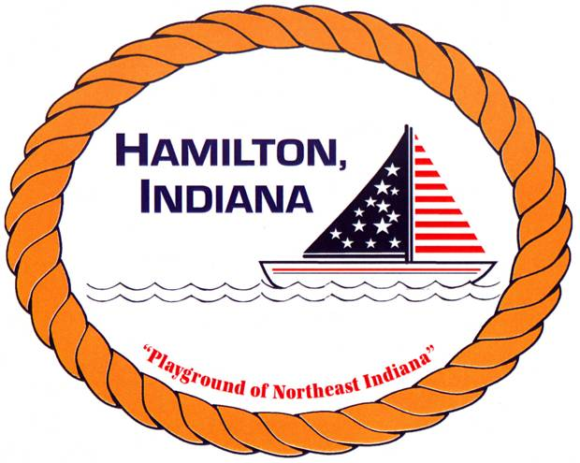

HAMILTON TOWN HYDROPONIC GARDENING

REGISTRATION FORM

Child(ren) Name _____________________________________________

Sex & Age___________________________________________________

Parent/Guardian Name _______________________________________

Phone ______________________________________________________

Has your child ever participated in a Hydroponic class or anything similar?
____________________________________________________________

June 4th & June 18th, 2019

9-11:00am – Ages 5 and up – LIMIT 15

Does your child have any medical conditions that could interfere with their participation in the Hydroponic class? (For example, asthma) _______________________________________________________________________

I agree to allow my son/daughter to attend the hydroponic class. My child cannot leave the premises on her/his own. I’m responsible for my child to be dropped off and picked up.

Parent Signature: _________________________________________________________

In the event that a parent can not pick son/daughter up, I authorize the following person/s.

Person Authorized ___________________________ Tel: _______________________

PLEASE NOTE: CLASSES WILL ONLY BE CANCELLED IN THE EVENT OF RAIN, THUNDER, AND/OR LIGHTNING.

