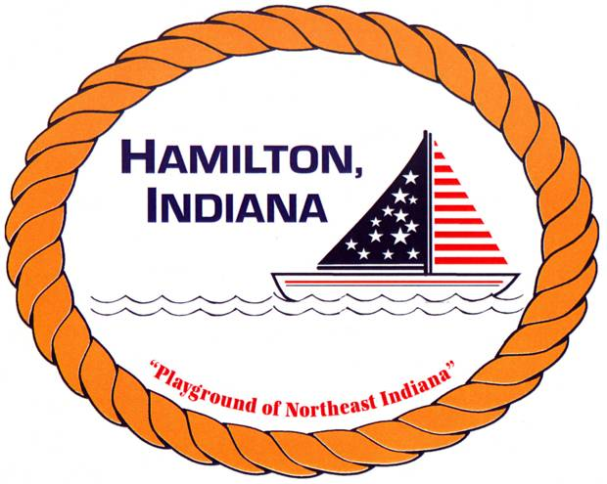

HAMILTON TOWN GOLF CLASS

REGISTRATION FORM

Child(ren) Name _____________________________________________

Sex & Age___________________________________________________

Parent/Guardian Name _______________________________________

Phone ______________________________________________________

Has your child ever participated in a Golf class or anything similar?
____________________________________________________________

July 8-12th, 2019

8-9:00am – Ages 6-9 LIMIT 10

9-10:30am – Ages 10 and up LIMIT 12

*** Friday July 12th, both clases will be together from 8-10:30am

Does your child have any medical conditions that could interfere with their participation in the Golf class? (For example, asthma) _______________________________________________________________________

I agree to allow my son/daughter to attend the Golf class at Cold Springs. My child cannot leave the premises on her/his own. I’m responsible for my child to be dropped off and picked up.

Parent Signature: _________________________________________________________

In the event that a parent can not pick son/daughter up, I authorize the following person/s.

Person Authorized ___________________________ Tel: _______________________

PLEASE NOTE: CLASSES WILL ONLY BE CANCELLED IN THE EVENT OF RAIN, THUNDER, AND/OR LIGHTNING.

