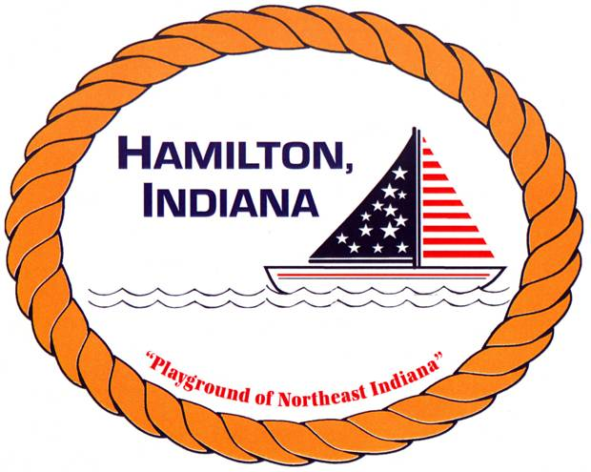

HAMILTON TOWN FISHING LESSONS

REGISTRATION FORM

Child(ren) Name _____________________________________________

Sex & Age___________________________________________________

Parent/Guardian Name _______________________________________

Phone ______________________________________________________

Has your child ever participated in a fishing class or anything similar?
____________________________________________________________

July 25 & 26th, 2019

8:30-10:00am – Ages 4-6 – LIMIT 10
10-11:30am - Ages 7-12 – LIMIT 12

Does your child have any medical conditions that could interfere with their participation in the Fishing class? (For example, asthma) _______________________________________________________________________

I agree to allow my son/daughter to attend the Fishing lessons at the Hamilton Fish & Game Club. My child cannot leave the premises on her/his own. I’m responsible for my child to be dropped off and picked up.

Parent Signature: _________________________________________________________

In the event that a parent can not pick son/daughter up, I authorize the following person/s.

Person Authorized ___________________________ Tel: _______________________

PLEASE NOTE: CLASSES WILL ONLY BE CANCELLED IN THE EVENT OF RAIN, THUNDER, AND/OR LIGHTNING.

