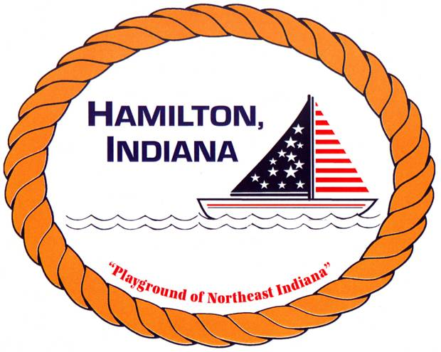

HAMILTON TOWN BACKYARD SPORTS

REGISTRATION FORM

Child(ren) Name _________________________________________________________

Sex & Age(s): ___________________________________________________________

Parent/Guardian Name ___________________________________________________

Phone ___________________________________

Has your child ever played any backyard sports? YES / NO (if yes, please list the sports)
________________________________________________________________________

June 17-21st, 2019 and July 15-19, 2019 – (Please circle the week you will be attending)

3-4 year olds – 9:15 – 10:00 am – LIMIT 10
5-6 year olds – 10-11:00 am – NO LIMIT
7-8 year olds – 11-12:00 pm – NO LIMIT

Does your child have any medical conditions that could interfere with their participation in the Program? (For example, asthma) ________________________________________________________________________

I agree to allow my son/daughter to attend Backyard Sports Classes at Gnagy Park. My child cannot leave the premises on her/his own. I’m responsible for my child to be dropped off and picked up.

Parent Signature: _________________________________________________________

In the event that a parent can not pick son/daughter up, I authorize the following person/s.

Person Authorized ___________________________ Tel: _______________________

PLEASE NOTE: CLASSES WILL ONLY BE CANCELLED IN THE EVENT OF RAIN, THUNDER, AND/OR LIGHTNING.

